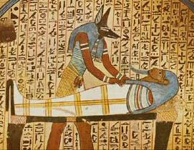 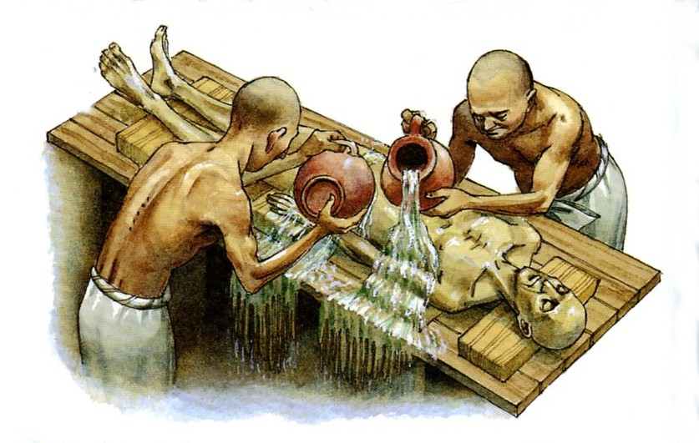

🙞 🙜

* A deceased body
* Water from the Nile
* Palm wine
* A cutting tool
* Natron
* Canopic jars
* A long hook
* Fragrant oils
* Linen
* Amulets
* A papyrus scroll
* A writing tool
* Liquid resin
* Cloth
* Paint
* A wooden board
* 2 coffins

#### You will need:

# Citations

# Materials

🙞 🙜

🙞 🙜

. *Ancient Egypt*. The British Museum, 20 Sep 1999. Web. 14 Dec 2013.

. "Mummification Process." *Angelfire*. N.p., n.d. Web. 14 Dec 2013. <http://www.angelfire.com/wi/egypt/mummy2.html>.

How To:

Egyptian

Mummification

### Egypt

### (3100 B.C.-30 B.C.)

Darianne Collins

1. “Ibu” means the “place of purification.
2. Do not remove the heart. It is the center of intelligence and feelings.
3. Natron is a natural salt.
4. Liver- Imsety Lungs- Hapy Stomach- Duamutef Intestines- Qebehsenuef
5. Save fluids and rags to be buried along with the body.
6. The fingers and toes are individually wrapped.
7. “Isis Knot” amulet- protects the body. “Plummet” amulet- for balance.
8. A picture of Osiris will be painted on it.

# Mummification in 17 easy steps

**Step 1:** Bring the body to “ibu,” a tent where the body is purified. **1**

**Step 2:** Wash the body with palm wine and water from the Nile.

**Step 3:** Make a cut on the left side of the body to remove internal organs. **2**

**Step 4:** Wash and fill the liver, stomach, lungs and intestines with natron. **3**

**Step 5:** Place the dried organs into its specific canopic jar. **4**

**Step 6:** Bring the brain out through the nose using a hook.

**Step 7:** Fill the body with natron. **5**

**Step 8:** Repeat step 2 after forty days.

**Step 9:** Apply oil to the skin.

**Step 10:** Wrap the body in linen. **6**

**Step 11:** Place amulets within the layers of linen. **7**

**Step 12:** Place a scroll with spells from the Book of the Dead between the hands.

**Step 13:** Wrap more layers of linen around the body using liquid resin.

**Step 14:** Wrap the body in cloth. **8**

**Step 15:** Wrap a larger cloth around the body.

**Step 16:** Place a painted wooden board atop the body.

**Step 17:** Place your mummy into the first coffin and then into a second coffin.

**St**